CUSAT-RUSA Startup Fund 2021
1.0 Introduction
Promoting entrepreneurial skills among the students is an investment for the future. Universities have a major role to play in this context. CUSAT has set up a TBI (CITTIC) within a space of 4000 square feet in the year 2017. We are happy that more than 50 startup companies are incubated in CUSAT currently. With financial support from RUSA, CUSAT has started a new state of the art TBI named RISE under CUSATECH FOUNDATION. This TBI facility consists of a dedicated Software IT space for leasing to startup firms. There will be a Biotech incubator with state of the art facilities that can be used by startup firms for nominal charges. A FABLAB has been setup in association with Kerala Startup Mission where 3D Printers, CNC machines, etc are available for incubates. Being part of CUSAT startup activities gives your company access to all these facilities at a discounted rates.
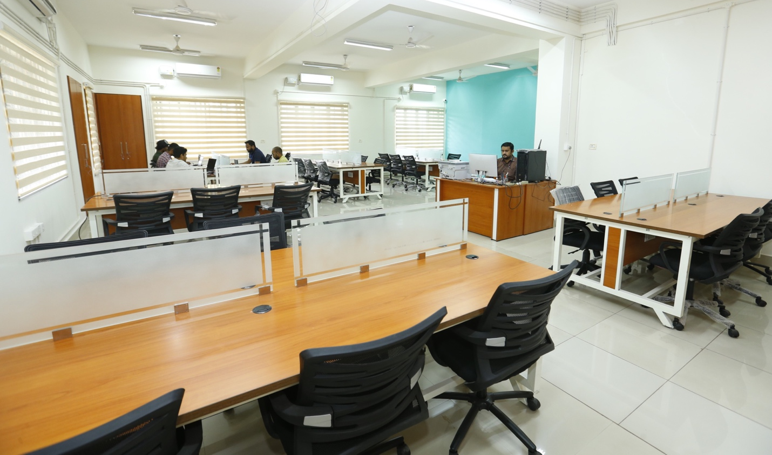
Figure 1: RISE Software Startup facility at CUSAT
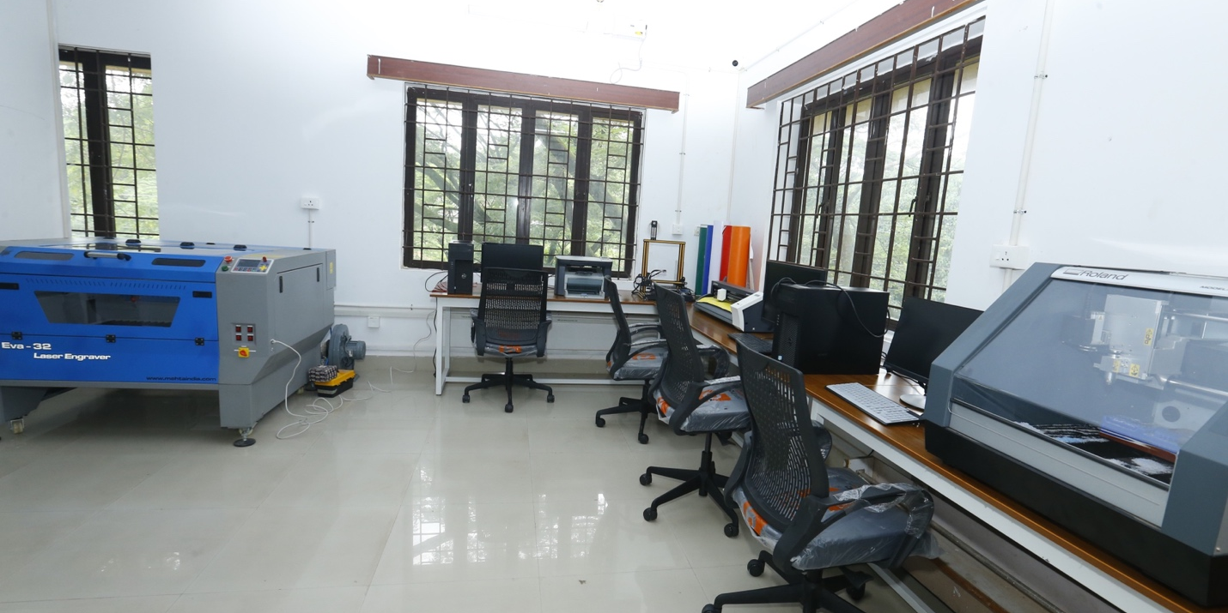
Figure 2: FABLAB facility at CUSAT
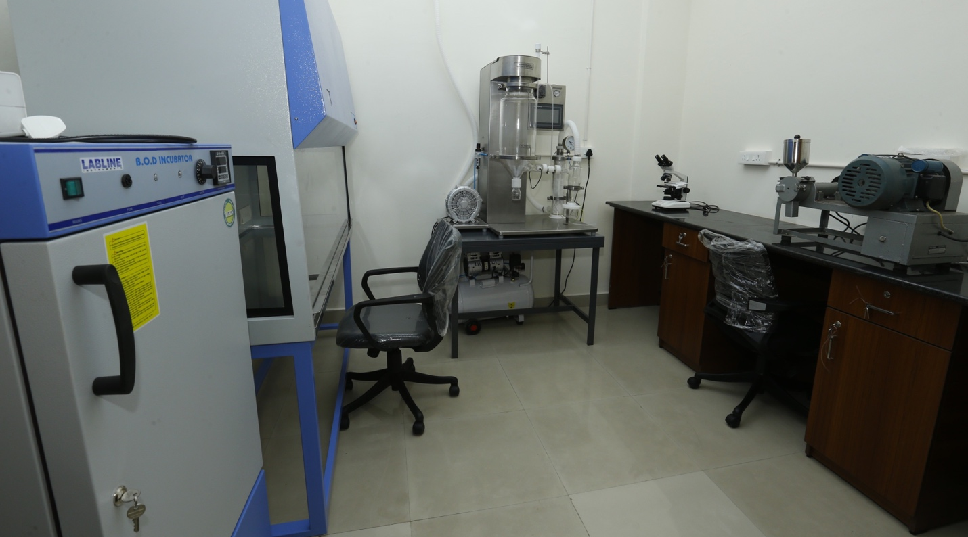
Figure 3: Biotech incubator facility at CUSAT
Early stage funding is challenging for innovators, especially student startups, as Angel Investors and VC’s consider investing at this stage to be very risky. It is not easy for the innovators to get business loans from financial institutions either. The premier institutions like IITs have setup startup funds to help their incubates. Understanding this challenge, CUSAT has decided to set up a startup fund under CUSAT-TBI to help our incubates convert their innovative ideas into full-fledged ventures.
2.0 Fund Details
Startups are entrepreneurial ventures seeking to develop and deploy innovative, technology driven solutions with a scalable business model. This scheme is designed as a non-refundable grant sponsored by CUSATECH FOUNDATION and is implemented through its TBI hub. The objective of this grant is to invite startups enthusiasts across India, who may or may not have a connection with CUSAT currently to setup or start an additional unit, and run university- connected start-up companies leveraging on the expertise of CUSAT
2.1 Eligibility
You are eligible to apply for an idea grant, if you are a Faculty / Staff /student of CUSAT planning to incubate a startup at CUSAT
You are eligible to apply for a product grant, if you are an Indian citizen planning to incubate a new startup or to start an additional unit of your existing startup at CUSAT.
Note
- Startups incubated elsewhere can apply if they are planning to associate with CUSAT-TBI if selected. Special discounts on incubation charges will be given to startups from CUSAT Alumni
- We strongly recommend formation of idea startups with CUSAT faculty as mentors / advisors. Faculty startup ownership terms will be governed by the entrepreneurship policies set by CUSAT.
2.2 Grant Schemes
- Idea Grant: ( From Idea to Product)
This is for potential startups consisting of faculty/staff/students of CUSAT, who have a brilliant idea / research output which they want to commercialize. This initial grant can be utilized for purposes like R&D and Consultancy expenses, market feasibility studies, Prototype development, rental expenses in incubator etc. The maximum amount is limited to Rs 2 lakhs
- Product Grant: ( From Product to Market)
This meant for startups who are already in operation. They should have completed their prototype/ MVP and should be seriously looking at going to the market. This grant will cover expenses towards final product development, product launch, market promotion, scaling up production etc. The maximum amount is limited to Rs 10 lakhs.
Note
The innovation grant cannot be used for the salaries for the founders and purchase of personal assets and gadgets. Purchase of equipment, fixed assets and devices may be permitted on a case to case basis. The purpose of the grant is to help startups grow faster. Startups may use this grant for R&D work, fabrication/ synthesis, product promotional activities, hiring specialized resources, product improvements, patent filing etc.

3.0 Process of selection
The applicant should apply for the respective grant in the prescribed format which contains a write up on their proposal highlighting the idea, value proposition, present status and future potential. They should also submit the details of the grant requested with necessary split up of expenditure heads.
A panel of experts setup by CUSATECH FOUNDATION may short list the applicants. The shortlisted applicants will be invited for a detailed presentation on their proposal. The presentation will be judged by an eminent panel consisting of industry representative, startup experts and academicians. The panel will recommend award of appropriate grant based on a range of criteria including
- Usefulness of the idea / solution
- Soundness of the applied Science / Technology used
- Potential for growth
- Commitment and expertise of the team
- Business model / Path to viability
- Proposed utilization of grant
- Proposed time lines
The Screening Panel will recommend the amount of grant to be awarded and also make suggestions regarding what this fund should be used for by the startup. The Screening Panel may also recommend interim and final milestones to be achieved by the startup. Where necessary, the Screening Panel may also recommend to have a technical review of the idea to be done before the award of the grant.
4.0 Sanction of Grants
The recommendations of the Screening Panel will be submitted to the CUSATECH FOUNDATION. Subject to the approval by the company, the selected startups will be notified. Additional reviews if necessary will be arranged by the CUSATECH FOUNDATION
The grant will be disbursed in milestone based tranches. Mode of payment will be through account payee cheque / bank transfer to the startup company account after collecting necessary documentation. If the startup has availed any other funding from any Government agencies, a utilization certificate and report needs to be submitted.
5.0 Progress Assessment
CUSATECH FOUNDATION will assess the progress before the disbursement of second / subsequent tranches. The startup should submit a progress report and fund utilization details to claim the next tranche of funds. The progress will be reviewed by a committee of experts set up by CUSATECH FOUNDATION before the balance amount is released.
Application can be downloaded from CITTIC website (LINK HERE) and submitted via email to tbi@cusat.ac.in on or before 31st October 2021.
You may contact Dr Sam Thomas (9846152127) Co-ordinator, CUSAT-TBI or Dr Bijoy A. Jose (9900634422), Deputy Co-ordinator, CUSAT-TBI for any clarifications.

